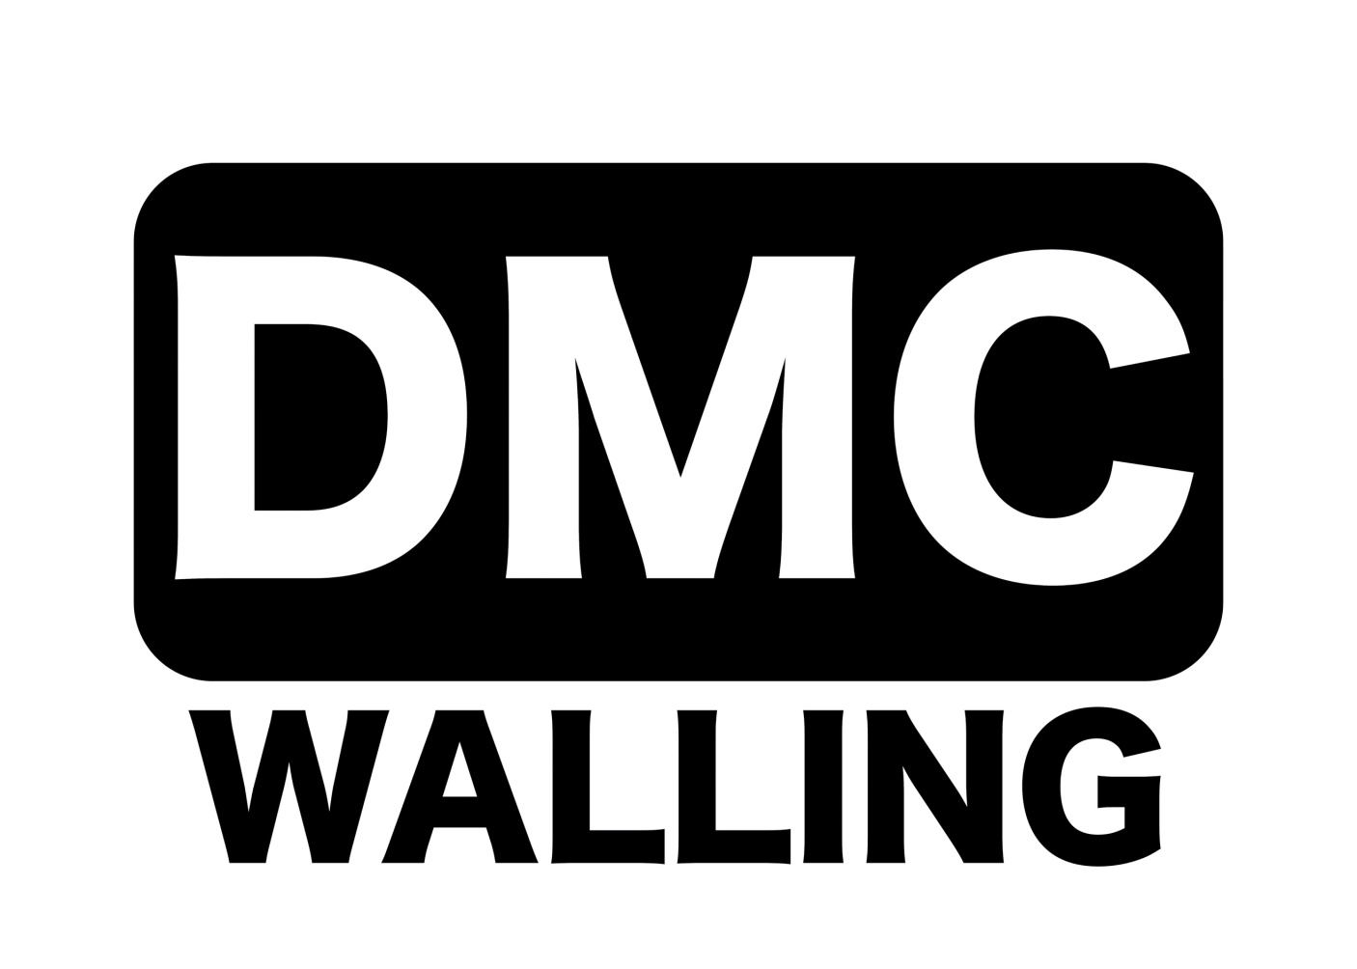
Founded 1900
Promoted for and on behalf of Cycling Time Trials under their Rules & Regulations

RESULTS
VICTORIA CYCLING CLUB

Co-Sponsored by DMC Walling, Alfresco Europe Solutions

Results for 23rd July 2022

10.2m 2-Up T.T.T/Solo Scratch - Points League #2 of #3

EVENT H.Q. Open 6.30am EVENT SECRETARY:Andrew Beaman ASSIS. EVENT SECRETARY:
Lea valley cycling hut 8 Colson road Sean Gray
Loughton IG103RN
North Hall Road
Ugley, Essex Mobile: 07723392837 Mobile: 07917-828944
CM22 6JD
Timekeepers: Frida Weizel (Lea Valley C.C.) : Ian Taylor (Lea Valley C.C.)

PRIZE LIST FOR ALL RIDERS
PLEASE LET ME SAY THANK YOU TO ALL WHO HELPED TODAY AND LEA VALLEY CC FOR HUT. A SPECIAL MENTION TO ALL PRIZE WINNERS EVERYONE OF THEM DONETED WINNINGS TO CHARITY

THIS EVENT RASED £180.00 FOR HAVEN HOUSE CHILDRENS HOSPICE.
1ST R Simmons £25.00 1st D Halliday £25.00
2nd J Freeman £17.50 2nd A Salmon £17.50
3rd M Free £10.00 3rd K Dorling £10.00

2UP
1st M Donovan & J Macrae £30.00
TEA M OF THREE
1st M Saunders M Ozdenya M Saunders £ 20.00

Thank you all for supporting this event. It was great see so many happy faces enjoying what they love. See you all 27th August. Thanks to Dave Knock for donating his marshal fees £20.00

SOLO, COURSE & EVENT RECORD
ALEX DOWSETT, TREK-LIVESTRONG : 19.47

.

